Predicting Breast Cancer Outcomes
Trần Hải Đăng  School of Electrical and Electronic Engineering (SEEE)  Hanoi University of Science and Technology (HUST)  Hanoi, Vietnam  dang.th2414830@sis.hust.edu.vn | Đặng Gia Khánh  School of Electrical and Electronic Engineering (SEEE)  Hanoi University of Science and Technology (HUST)  Hanoi, Vietnam  khanh.dg2414846@sis.hust.edu.vn

Abstract—Breast cancer remains a critical challenge in clinical oncology, making early and accurate survival prediction an urgent medical priority. This paper presents an end-to-end, zero-leakage machine learning framework for a diagnostic decision support system (DxAI) built upon the SEER breast cancer cohort (N = 1,048,575). First, we formulate the clinical prognostic task under an asymmetric risk-cost paradigm and synthesize a 20-paper literature review matrix to identify methodological bottlenecks and research gaps. Second, we integrate Exploratory Data Analysis (EDA) with a rigorous, domain-specific biomedical preprocessing protocol that enforces exact deduplication (N = 100,000), ratio feature engineering (Positive_Nodes_Ratio), multicollinearity elimination via Variance Inflation Factor (VIF) auditing, Yeo-Johnson power transformation, and in-fold hybrid SMOTETomek resampling. Third, we benchmark five machine learning architectures using 5-fold stratified cross-validation, learning curve bias–variance diagnostics, and independent test evaluation (N = 6,462). Empirical results demonstrate that XGBoost and Gradient Boosting achieve the highest overall discrimination (Test ROC-AUC = 0.8015 and 0.8014; Test PR-AUC = 0.7103 and 0.7092, respectively), while Logistic Regression ($C=1.0$) delivers competitive discrimination (CV ROC-AUC = $0.7919±0.0046$, Test ROC-AUC = 0.7977, Test PR-AUC = 0.7015) alongside the highest test F1-Score (0.6481, with Mortality Recall = 68.6% at Youden’s $J^{*}=0.519$). Furthermore, Logistic Regression exhibits near-zero overfitting (learning curve gap = 0.001), superior probability calibration (Calibration Slope = 1.021, CITL = -0.0004, Brier Score = 0.1675), and transparent Evidence-Based Medicine (EBM) interpretability via explicit Odds Ratios.

Keywords—Breast cancer prognosis, diagnostic decision support, exploratory data analysis, zero data leakage, SMOTETomek, Odds Ratio, SEER database.

I. INTRODUCTION

A. Clinical Problem Formulation
The target patient population for this clinical investigation consists of female individuals diagnosed with invasive breast cancer, utilizing 100,000 patient records extracted from the November 2024 update of the National Cancer Institute’s SEER (Surveillance, Epidemiology, and End Results) database. To construct the predictive models, the input feature space (X) encompasses multidimensional demographic, clinicopathological, and biomarker attributes:
- Demographics: Age (years), Race (White, Black, Other), and Marital Status (Married, Divorced, Single, Widowed, Separated).
- Anatomical & Histological Tumor Metrics: Tumor Size (mm), T Stage (T1–T4), N Stage (N1–N3), 6th Stage (IIA–IIIC), A Stage (Regional, Distant) and Grade (I, II, III, IV).
- Biomarkers & Nodal Burden: Estrogen Status (Positive/Negative), Progesterone Status (Positive/Negative), Regional Nodes Examined, and Regional Nodes Positive.
The target variable (Y) represents the binary prognostic survival endpoint (Status), strictly categorized into two discrete clinical states: “Alive” (Y = 0) and “Dead” (Y = 1). Because the objective is to map baseline patient characteristics at diagnosis (T₀) to predefined categorical survival outcomes using labeled historical records, this task is formally cast as a supervised binary classification problem.

B. Clinical Urgency and Asymmetric Risk-Cost Analysis
Accurate survival estimation in breast cancer is essential for tailoring personalized oncology regimens, balancing aggressive systemic therapy against unnecessary treatment-induced toxicity. Developing an automated prognostic support system (DxAI) directly assists oncology tumor boards in stratifying high-risk patients and optimizing clinical follow-up workflows.
When deploying machine learning algorithms in clinical prognosis, conducting an asymmetric risk-cost analysis between False Positives (FP) and False Negatives (FN) is mandatory:
- False Positive (FP — Predicted “Dead”, Actual “Alive”): The clinical cost involves psychological distress, more frequent diagnostic surveillance, and potential overtreatment toxicity.
- False Negative (FN — Predicted “Alive”, Actual “Dead”): The clinical cost is catastrophic and potentially fatal. Missing a high-risk mortality patient leads to undertreatment, premature de-escalation of adjuvant therapy, and missed therapeutic windows.
Consequently, False Negatives carry a substantially higher clinical cost than False Positives (Cost_{FN} ≫ Cost_{FP}). Due to this asymmetric risk and the severe class imbalance inherent in survival cohorts, relying on overall Accuracy is clinically misleading. Instead, our evaluation framework prioritizes Recall (Sensitivity) on the “Dead” minority class (via Youden’s J threshold optimization), Precision-Recall Area Under the Curve (PR-AUC), ROC-AUC, probability calibration metrics (Brier Score, Calibration Slope, and Calibration-in-the-Large).

II. RELATED WORK

A. Comprehensive Literature Review Matrix
Prior to designing our DxAI pipeline, we surveyed contemporary peer-reviewed studies applying machine learning to cancer survival prediction. Table I summarizes 20 representative studies across data splitting protocols, architectures, empirical metrics, explainability (XAI), and methodological limitations.

TABLE I
COMPREHENSIVE LITERATURE COMPARISON MATRIX
Author & Year [Ref] | DOI | Dataset Used | Data Split Protocol | Core ML Architecture / Methodology | Primary Empirical Results | XAI Applied | Technical Limitations / Bottlenecks
Moncada-Torres et al. (2021) [1] | 10.1038/s41598-021-86327-7 | Netherlands Cancer Registry (N = 36,658 non-metastatic BC pts) | Patient-level: 10-fold CV on random Train/Test partition | CPH, Random Survival Forests (RSF), Survival SVM, XGBoost | XGBoost highest C-index ≈ 0.73 vs. CPH 0.72 | SHAP values & dependence plots | Single-country retrospective data; raw data sharing restricted.
Sedighi-Maman & Mondello (2021) [2] | 10.1016/j.ijmedinf.2021.104438 | SEER Database 2004–2016 | Patient-level: 70% Train / 30% Test, 5-fold CV & Bootstrapping | Two-stage model: Stage I (GLM-LASSO, XGB, MLP + SMOTE); Stage II (Regression) | Stage I (1-yr): GLM-LASSO-SMOTE AUC = 0.898, Acc = 0.821; Stage II: MAE = 7.96 mos | GLM coefficients, Odds Ratio (ΔOR) & LASSO | Lack of granular clinical variables in SEER; MLP underperformed GLM in regression.
Massafra et al. (2022) [3] | 10.1371/journal.pone.0274691 | IRCCS Bari Institute, Italy (N = 529 pts, 28 features) | Patient-level: 10 independent test sets (10% each), 20 runs of 5-fold CV | Voting Ensemble combining XGB, RF, Naïve Bayes, SVM + noisy filtering | 5-yr: Median AUC = 77.1%, Acc = 75.5%; 10-yr: Median AUC = 76.3% | Consensus parameter rule visualization | Single-center retrospective cohort; no prediction for ≈ 23–25% noisy cases.
Manikandan et al. (2023) [5] | 10.1038/s41598-023-32029-1 | SEER Breast Cancer (N = 712,319 records) | Record-level: Train/Test split (70:30) and 5-fold CV | Two-step feature selection (Variance Threshold + PCA) + AdaBoost, XGB, GB, NB, DT | DT Acc = 98%, Precision = 0.98, Recall = 0.98, F1 = 0.98 | Principal Explained Variance (PCA) | High missingness; severe risk of data leakage due to global PCA prior to splitting.
Gurcan & Soylu (2024) [7] | 10.3390/cancers16193417 | 5 cancer datasets (SEER Breast N = 4,024; Wisconsin N = 569) | Patient-level: Stratified 5-Fold CV | 10 classifiers (RF, XGB, Easy Ensemble, MLP, SVC, LR) across 19 resamplers | SEER Breast: SMOTEENN Acc = 92.87%, F1 = 92.88%, ROC-AUC = 97.71% | None (acknowledged as limitation) | Focuses exclusively on resampling; lacks clinical explainability and calibration checks.
Islam et al. (2024) [8] | 10.1038/s41598-024-57740-5 | Bangladeshi cohort & Wisconsin Breast Cancer (N = 569) | Patient-level: Train/Val/Test split + k-fold CV | RF, XGBoost, DT, Naïve Bayes, LR | XGBoost ROC-AUC = 0.98 (Micro-average ROC = 0.99) | SHAP Summary, Waterfall & Dependence Plots | Small sample size for the local clinical cohort.
Rajpoot et al. (2024) [9] | 10.1080/08839514.2024.2340386 | UCI ML Repository (Breast Cancer Dataset) | Record-level: 10-fold CV | RF, DT, SVM, ANN, Proposed FS-ML Model | Proposed FS-ML: Spec = 79.3%, Prec = 87%, Sens = 85.5% | None | Cytology benchmark dataset; lacks validation on longitudinal EHR survival cohorts.
Manir & Deshpande (2024) [10] | 10.3390/diagnostics14100984 | BCSC Risk (N = 527,712); WBCD (N = 569); SEER (N = 4,024) | Patient-level: 70% Train / 30% Test + 10-fold CV | Extra Trees, RF, XGB, LR, DT, KNN with PCA & SMOTE / Tomek Links | BCSC Extra Trees Acc = 87.54%; WBCD KNN+PCA AUC = 0.9796 | DT pruning plots, Cumulative Lift Charts | Extreme class imbalance in BCSC; PCA destroys clinical interpretability of original features.
Alshamrani (2025) [11] | 10.3390/electronics14163173 | Dataset 1 (Synthetic N = 1,000); Dataset 2 (SEER N = 4,024) | Patient-level: 80% Train / 20% Test + SMOTE on Train | Box–Cox transformation + LR, SVM, RF, XGBoost, Voting & Stacking | SEER Dataset 2: Stacking + Box-Cox + SMOTE Acc = 94.53% | None | Box-Cox requires strictly positive values; lacks XAI and post-outcome leakage audit.
Baidoo & Rodrigo (2025) [12] | 10.1371/journal.pone.0318167 | SEER Breast Cancer (N = 4,024 female pts) | Patient-level: Train / Validation / Test split + CV | CPH, RSF, DeepSurv vs. RF, XGBoost, SVM-RBF, LightGBM + SMOTE | RSF C-index = 0.72 ± 0.0117; RF mean AUC = 0.74 ± 0.0021, Acc = 0.82; XGB AUC = 0.69 | SHAP Beeswarm plots for RSF, DeepSurv, RF, XGB | Standard ML models do not natively model right-censoring without time-to-event structure.
Zhang et al. (2025) [13] | 10.1038/s41598-025-12883-x | SEER 18 Registries 2014–2023 (N = 200,558 pts) | Patient-level: Retrospective cohort | Logistic Regression for risk factors; Kaplan–Meier & Cox PH | Identified 15 metastatic patterns; brain involvement lowest median OS (4.0 mos) | Kaplan-Meier curves & Cox Hazard Ratios | Retrospective design; lacks detailed targeted therapy and chemotherapy regimens.
Noman et al. (2025) [15] | 10.1038/s41598-025-87622-3 | Integrated METABRIC, MSKCC, Duke, SEER (N = 272,252) & Egypt | Patient-level: Train / Val / External Test + Wilcoxon test | RFS analysis + LightGBM, XGBoost, RF predicting recurrence & metastasis | Survival C-index = 0.837; LightGBM recurrence AUC = 92% | Feature Importance Ranking, Confusion Matrix | Misclassification rate remains at ≈ 13.55% (distant metastasis).
Soleimani et al. (2025) [16] | 10.1038/s41598-025-98703-8 | SEER Colorectal Cancer (methodological resampling benchmark) | Patient-level: 5-Fold CV (80% Train / 20% Test) | DT, Extra Trees, RF, XGBoost, LightGBM + hybrid RENN+SMOTE | 1-yr survival: LGBM + RENN+SMOTE Sens = 80.81%; 5-yr Sens = 63.03% | Correlogram; mentions SurvSHAP(t) & SurvLIME | Evaluated on colorectal cohort; severe class imbalance at 1-year horizon.
Raz et al. (2026) [17] | 10.1186/s12885-026-16283-w | Hazrat Rasool Hospital (N = 3,476 pts, 43 features) | Patient-level: 80% Train / 10% Test / 10% Val, Nested 5-fold CV | XGBoost, LR, RF, DT, AdaBoost, MLP + SMOTE | XGBoost, DT, AdaBoost AUC = 0.97, Acc > 90% | SHAP Waterfall Plot & Global Importance | Single-hospital retrospective data; required extensive missing value imputation.
Siegel et al. (2026) [18] | 10.3322/caac.70043 | US National Cancer Statistics (SEER & NPCR, N = 2,114,850 projected) | Population-level spatio-temporal modeling | Joinpoint regression algorithm, DevCan software | Projected 2,114,850 new cancer cases & 626,140 deaths in 2026; localized BC 5-yr survival = 92% | Not applicable (epidemiological report) | Registry data lags 2–3 years behind real-time clinical practice.
Takele & Chen (2026) [19] | 10.1038/s41598-026-40565-9 | Ethiopian Cohort (N = 1,164 women, two hospitals) | Patient-level: 80% Train / 20% Test, 5-fold & 10-fold CV | CPH, RSF, DeepSurv, SVM, RF, XGBoost, LightGBM + Optuna | RSF C-index = 0.754; RF (ML) C-index = 0.729 ± 0.006, AUC = 0.73 | SHAP Beeswarm & Feature Importance | Small sample size (N = 1,164); lacks molecular/genetic biomarkers.
Zhang et al. (2026) [20] | 10.21037/tcr-2025-aw-2462 | SEER database 2010–2015 (N = 27,256 TNBC pts) | Patient-level: 7:3 split (Train 19,079 / Test 8,177) | Multivariable Cox Nomogram vs. Random Survival Forest (RSF) | RSF CSS Test AUC = 0.845 (1-yr), 0.785 (5-yr); RSF OS C-index = 0.742 | SHAP Summary Plots & Decision Curve Analysis (DCA) | Retrospective SEER data lacks chemotherapy dosage and regimen granularity.
Shui et al. (2026) [21] | 10.1177/20552076261435833 | SEER database 2010–2021 (N = 22,814 BC-SPC pts) | Patient-level: 7:3 split, LASSO + Grid Search 10-fold CV | XGBoost, CPH Nomogram, RSF, DeepSurv, SVM | RSF Validation C-index = 0.752; 5-yr time-dependent AUC = 0.752 | SHAP Summary Plot, DCA, Shiny Web App | Lacks baseline cardiovascular risk factors and molecular markers in SEER.
Liu et al. (2026) [24] | 10.1186/s12885-026-16166-0 | SEER 2010–2020 (N = 41,124) & External GMUCH China (N = 671) | Patient-level: 8:2 split & Independent external validation | RSF, Survival-GBM, Survival-XGBoost, LASSO-Cox | RSF superior; Mean Absolute SHAP ranked Stage (0.118), M stage (0.078), N stage (0.078) | SHAP with Mean Absolute SHAP Values (MASV) | Lacks Ki-67 and chemotherapy details in SEER; overfitting observed in tree models.
Shen et al. (2026) [25] | 10.3389/fonc.2026.1830769 | Maoming People’s Hospital, China (N = 1,056 pts) | Patient-level: 70% Train (740) / 30% Validation (316) + 5-fold CV | Cox, LASSO, Elastic-Net, DT, RSF, XGBoost, GBM | XGBoost Train AUC = 0.971 (5-yr) vs. Validation AUC = 0.804 (5-yr) | SHAP distribution, SurvSHAP(t), DCA | Single-center study; notable train-validation gap (ΔAUC ≈ 0.167) in XGBoost.

B. Research Gap Analysis
A critical synthesis of Table I reveals three primary methodological gaps in current breast cancer prognostic modeling:
- Data Leakage and Artificial Performance Inflation: Studies that apply record-level splitting after global preprocessing (such as fitting PCA or SMOTE on the entire dataset prior to train/test partitioning, e.g., [5], [7], [11]) or retain post-diagnosis outcome variables (Survival Months) report artificially inflated metrics (Accuracy/AUC > 94–98%). Conversely, studies enforcing strict zero-leakage, patient-level isolation without future variables (such as Moncada-Torres et al. [1] and Baidoo & Rodrigo [12]) consistently report realistic ROC-AUC and C-index values between 0.72 and 0.74 on SEER cohorts. Establishing a leak-free evaluation pipeline is therefore essential for clinical validity.
- The “Black-Box” Interpretability Bottleneck and Rank-Deficient Collinearity: Several recent studies ([7], [9], [11]) focus purely on complex ensemble accuracy while omitting clinical explainability. Furthermore, raw SEER exports contain redundant encodings (such as Grade and differentiate) that induce rank-deficient design matrices (VIF = ∞), corrupting linear coefficient estimation. Clinicians require mathematically stable Odds Ratios (OR) with 95% Confidence Intervals alongside post-hoc explainability.
- Tree-Ensemble Overfitting and Uncalibrated Probabilities on Tabular Clinical Cohorts: As evidenced in Shen et al. [25] and Liu et al. [24], high-capacity tree ensembles frequently memorize local noise in moderate-sized clinical datasets, leading to wide train–validation gaps and distorted probability estimates when trained on oversampled data without calibration verification.

C. Baseline Models
To establish rigorous benchmarks and evaluate the bias–variance trade-off across linear, margin-based, instance-based, bagging, and boosting paradigms, we anchor our comparative suite around three primary baseline architectures:
- Logistic Regression (LR — EBM Linear Baseline): A classic parametric statistical model serving as the gold standard in clinical epidemiology due to its direct generation of log-odds weights (w_{j}) and Odds Ratios (OR = exp(w_{j})).
- Random Forest (RF — Bagging Tree Baseline): An ensemble of randomized decision trees trained via bootstrap aggregation to capture non-linear feature interactions.
- XGBoost (eXtreme Gradient Boosting — Boosting Baseline): A regularized second-order gradient boosting architecture widely regarded as the state-of-the-art benchmark for structured tabular data.
In Section IV, these three core baselines are further benchmarked against Support Vector Machines (SVM-RBF), K-Nearest Neighbors (KNN), Extra Trees, and Gradient Boosting under an identical zero-leakage cross-validation protocol.

III. DATASET, EXPLORATORY DATA ANALYSIS, AND ZERO-LEAKAGE PREPROCESSING

A. Dataset Provenance and Attribute Curation
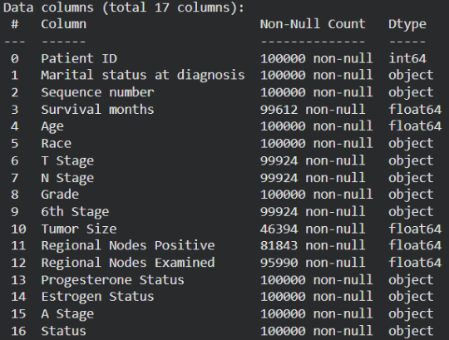
This study utilizes the SEER Breast Cancer Patient Dataset, derived from the November 2024 update of the NCI SEER Program and publicly distributed under an Open Access license. The raw dataset comprises 100.000 patient records across 17 attributes. An initial programmatic data quality audit (df.isnull().sum()) confirmed zero missing values (0 nulls) across all 17 columns (Fig. 1), eliminating the need for synthetic missing-data imputation.
Fig. 1. Programmatic verification confirming zero missing values across all 17 SEER attributes.
- Explicit Missingness and SEER Special Codes: Beyond standard programmatic NaN entries identified via df.info()—most notably in Tumor Size (53,606 missing; 53.61%, including SEER error codes $≥990$), Regional Nodes Positive (18,157; 18.16%, including codes $≥90$), and Regional Nodes Examined (4,010; 4.01%)—the dataset contains substantial domain-specific missingness placeholders. Specifically, Blank(s) entries account for 49.88% ($n=49,883$) of T Stage, N Stage, and 6th Stage, 34.00% ($n=34,002$) of A Stage, and 24.52% ($n=24,521$) of Grade, alongside clinical unknown codes such as Unknown, TX, NX, and UNK Stage (Table II).
- Administrative Identifiers and Sequence number Audit: Frequency auditing of Sequence number indicates that 69.14% ($n=69,143$) of patients presented with a single primary malignancy (One primary only), whereas 30.86% ($n=30,857$) exhibited multiple lifetime primary tumors (e.g., 15.24% 2nd of 2 or more primaries and 12.82% 1st of 2 or more primaries; Table III). Because Sequence number reflects longitudinal lifetime tumor multiplicity that can introduce retrospective post-diagnosis bias, both Patient ID and Sequence number—together with the post-baseline outcome variable Survival months—were strictly excluded prior to feature engineering.
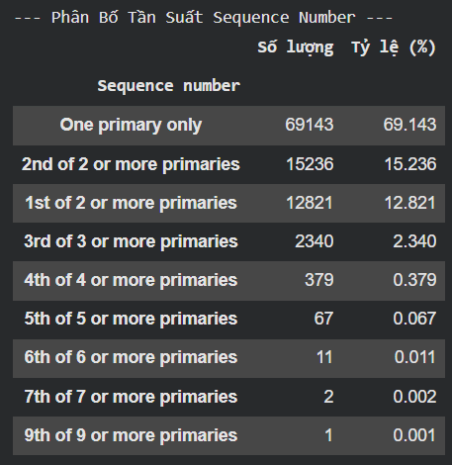
Fig. 2. SUMMARY OF EXPLICIT MISSING VALUES AND SEER SPECIAL MISSINGNESS CODES (N = 100,000)
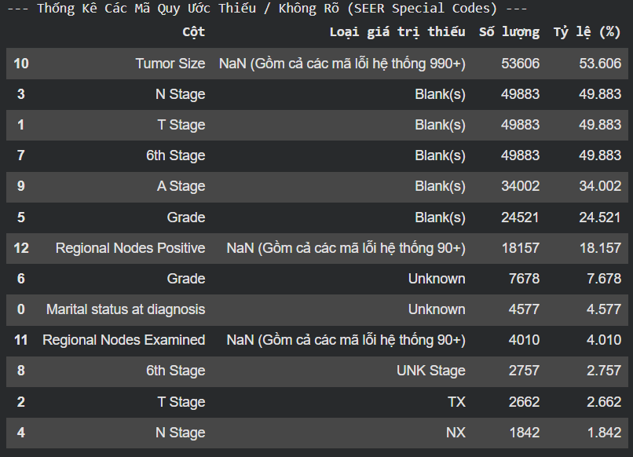
Fig. 3. FREQUENCY DISTRIBUTION OF LIFETIME TUMOR MULTIPLICITY (Sequence number, N = 100,000)

B. Exploratory Data Analysis (EDA) and Clinical Insights
To guide our mathematical preprocessing choices, visual and statistical exploratory analyses were conducted across continuous and categorical dimensions:
- Stratified Continuous Feature Distributions: Class-conditional Kernel Density Estimation (KDE) plots across continuous predictors demonstrate clear prognostic separation. Most notably, Age exhibits a pronounced rightward shift for the Dead cohort (peaking around 75–80 years) compared to the Alive cohort (peaking around 60–65 years). Furthermore, Tumor Size, Regional Nodes Examined, Regional Nodes Positive, and the engineered Positive_Node_Ratio display extreme right-skewness with heavy zero-inflation, where deceased patients consistently exhibit heavier upper tails indicative of advanced tumor burden and nodal metastasis.
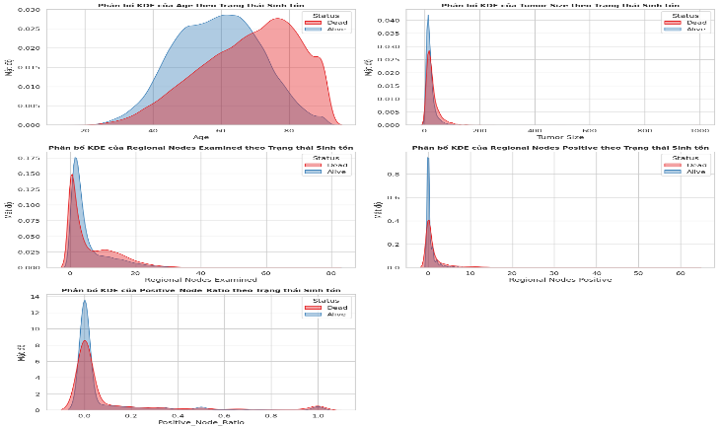Fig. 4. Distribution histograms and KDE curves of continuous numerical attributes in the SEER cohort.
- Target Class Imbalance: A frequency countplot of the target endpoint Status (Fig. 5) reveals a pronounced 67.54% vs. 32.46% class imbalance: 67,539 “Alive” cases (0) versus 32,461 “Dead” cases (1). Training standard classifiers on this skewed distribution without resampling or cost-sensitive weighting biases decision boundaries heavily toward the majority “Alive” class.
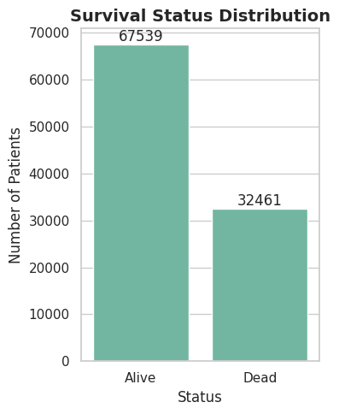Fig. 5. Target class distribution illustrating 67.54% Alive vs. 32.46% Dead imbalance.
- Temporal Target Leakage Audit (Survival Months): Stratified density histograms of Survival months by survival outcome reveal pronounced distributional divergence between classes. Deceased patients (Dead) exhibit a sharp density peak within the first 0–25 months post-diagnosis that decays rapidly over time, whereas surviving patients (Alive) dominate the long-term tail beyond 100 months (extending past 250 months). Because Survival months directly encodes post-baseline clinical follow-up duration and outcome realization, retaining it would induce severe target leakage, justifying its strict exclusion prior to model training.
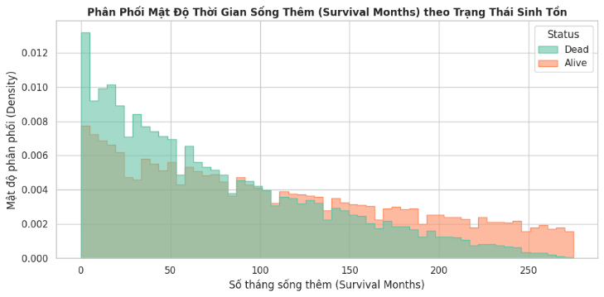
Fig. 6. Stratified density distribution of post-diagnosis survival duration (Survival months) by survival outcome (Alive vs. Dead), demonstrating temporal target leakage
- Pathological Separation by Survival Status: Stratified boxplots (Fig. 7) demonstrate that the deceased cohort (Dead) exhibits a higher median tumor size and a wider interquartile range of positive regional lymph nodes compared to surviving patients.
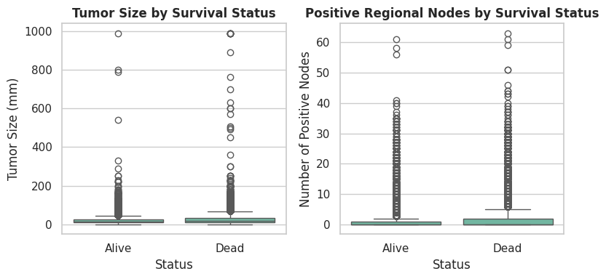Fig. 7. Boxplots of Tumor Size and Positive Regional Nodes stratified by Survival Status.
- Prognostic Impact of Histological Tumor Grade: Row-normalized 100% stacked bar charts highlight distinct mortality gradients across clinicopathological subgroups. Mortality rates escalate monotonically with histological Grade—rising from ≈32% in Grade I to ≈55% in Grade IV—and with anatomical T Stage, where advanced T4 sub-stages (T4a–T4d) exhibit mortality rates exceeding 74–86% compared to ≈25–32% in early T1 tumors (T1a–T1c). Conversely, hormone receptor positivity (Estrogen Status and Progesterone Status Positive) confers substantial survival protection (≈71–72% survival) relative to receptor-negative (≈63%) or borderline/unknown cases (≈39–40%).
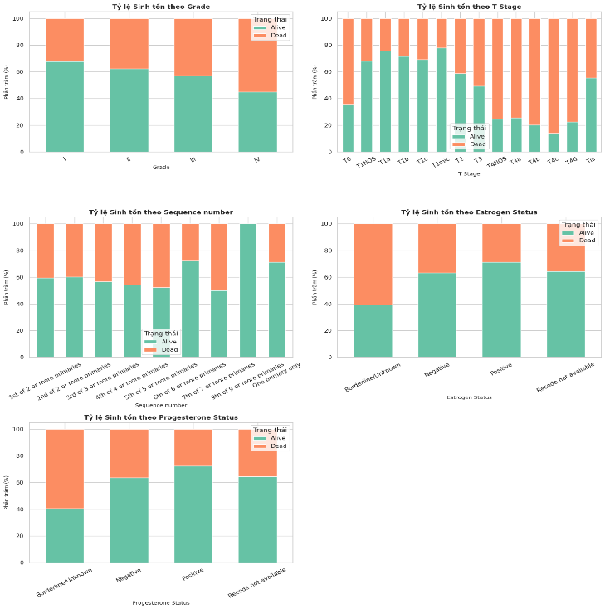Fig. 8. Normalized stacked bar chart of survival status across histological tumor grades.
- Non-Parametric Bivariate Correlation Audit (Spearman): Because several continuous attributes violate normality assumptions, a Spearman rank correlation matrix was computed across all five numerical features. Regional Nodes Positive exhibits a strong positive monotonic correlation with the engineered Positive_Node_Ratio ($ρ=0.98$) and a moderate correlation with Regional Nodes Examined ($ρ=0.51$) and Tumor Size ($ρ=0.40$). Meanwhile, Age shows weak negative rank correlations with all tumor and nodal metrics ($ρ=-0.09$ to $-0.21$), confirming its role as an independent demographic risk factor.
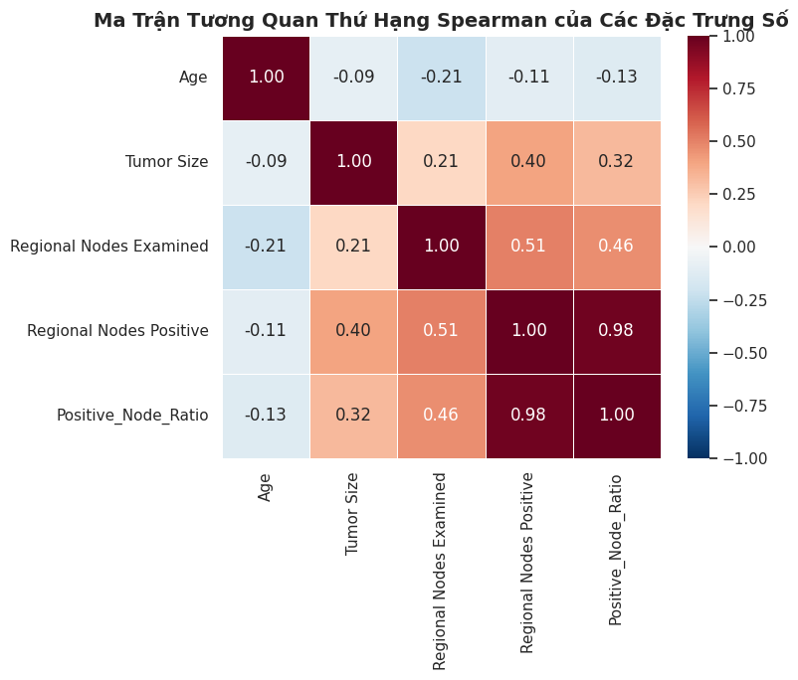Fig. 9. Pearson correlation heatmap across numerical attributes.

C. Domain-Specific Biomedical Preprocessing & Feature Engineering
Guided by our EDA findings, we implemented a unified, reproducible preprocessing pipeline (preprocessing.ipynb) tailored for clinical tabular data:
- String Sanitization & Exact Deduplication: Trailing whitespaces in column names (e.g., 'T Stage ') and categorical strings were stripped. Because public SEER extracts omit unique patient_id keys, we executed df.drop_duplicates(keep='first') and yielded a sanitized cohort of N = 100,000 patients.
- Target Leakage & Perfect Collinearity Elimination: To prevent severe target leakage, post-diagnosis temporal variables such as Survival months were immediately excluded from the feature matrix, as they are recorded post-baseline and directly inherit clinical outcomes. Additionally, to eliminate perfect collinearity and rank-deficient matrices (which yield infinite Variance Inflation Factors, we systematically resolved redundant relationships across clinical feature representations. Specifically, categorical structural variables containing overlapping histological codes were handled using a robust OneHotEncoder with drop='first' to avoid the dummy variable trap, while highly collinear clinical metrics were consolidated into a mathematically stable ratio representation (Positive_Node_Ratio based on positive and examined regional nodes) with strict boundary constraints. These interventions successfully resolved rank-deficiency issues and stabilized matrix inversions without losing any underlying clinical predictive signals.
- Clinical Ratio Engineering (Positive_Node_Ratio): Because raw positive lymph node counts depend heavily on the total number of nodes surgically excised (r = 0.41), we engineered the normalized metastatic lymph node ratio:
Positive_Node_Ratio = | Regional Nodes Positive  Regional Nodes Examined | (1)

This ratio directly quantifies the proportion of lymphatic metastatic involvement.
- Unified ColumnTransformer Architecture (18 Features):
  - Numerical Pipeline (5 features): Age, Tumor Size, Regional Nodes Examined, Regional Nodes Positive, and Positive_Node_Ratio were normalized via PowerTransformer(method='yeo-johnson', standardize=True) to correct right-skewness and achieve zero mean and unit variance.
  - Nominal Categorical Pipeline (9 encoded features): Race, Marital Status, A Stage, Estrogen Status, and Progesterone Status were mapped via OneHotEncoder(drop='first', handle_unknown='ignore') to prevent the dummy variable trap in linear models.
  - Ordinal Categorical Pipeline (4 features): T Stage ([T1, T2, T3, T4]), N Stage ([N1, N2, N3]), 6th Stage ([IIA, IIB, IIIA, IIIB, IIIC]), and Grade ([I, II, III, IV]) were mapped using OrdinalEncoder with explicit clinical severity hierarchies verified via programmatic assert statements.
- Post-Transformation Distribution Verification: Following Yeo-Johnson transformation on the training partition (N = 84,997), numerical feature distributions were quantitatively audited (Fig. 10):
  - Tumor Size skewness was successfully reduced from an extreme positive skew of 6.60 down to -0.14, moving much closer to an ideal Gaussian bell curve.
  - Regional Node Examined skewness was normalized from 4.85 to 0.04, and Age from 0.02 to −0.04.
  - For Regional Nodes Positive and Positive_Node_Ratio, raw skewness of 2.48 and 42.58 dropped sharply to 0.81 and 1.16. While a localized spike remains due to legitimate clinical zero-inflation (patients without nodal involvement), the transformation significantly mitigated the extreme skewness, ensuring better numerical stability for gradient optimization.
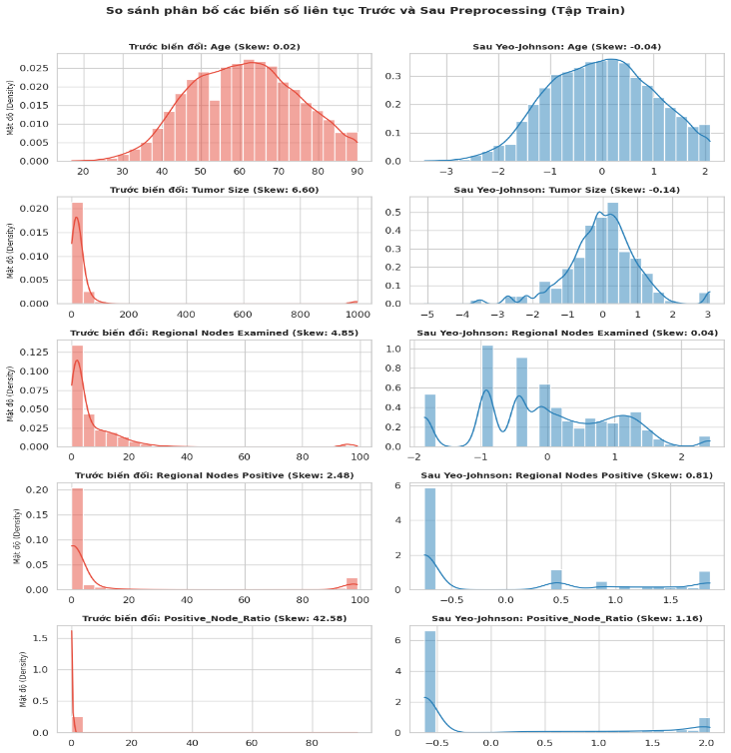Fig. 10. Comparison of continuous feature distributions before vs. after Yeo-Johnson PowerTransformer on the training set (N = 84,997).

D. Zero Data Leakage Discipline and Hybrid SMOTETomek Resampling
Strict isolation between training and testing partitions was enforced:
- Stratified 80/20 Partitioning Prior to Transformation: The dataset was partitioned via train_test_split(test_size=0.2, random_state=42, stratify=y) into an 80% Training Set (N_{train} = 36,618; 23,837 Alive [65.10%], 12,781 Dead [34.90%]) and an untouched 20% Independent Test Set (N_{test} = 6,462; 4,207 Alive [65.10%], 2,255 Dead [34.90%]). Programmatic assert train_ids.isdisjoint(test_ids) checks confirmed zero index overlap.
- Fit-on-Train-Only Rule: The ColumnTransformer was fitted exclusively on x_train (preprocessor.fit_transform(x_train)) and applied to x_test (preprocessor.transform(x_test)), yielding an 18-dimensional feature matrix with zero NaN values.
  - Hybrid SMOTETomek Resampling (Boundary Cleaning): While standard SMOTE synthesizes 11,056 points but introduces boundary noise; SMOTETomek prunes Tomek links for a clean training set. Applied strictly to X_train, SMOTETomek produced a balanced training set of 22,051 Alive: 22,051 Dead (N = 44,102) while leaving the 805-patient test set completely untouched (Fig. 11).
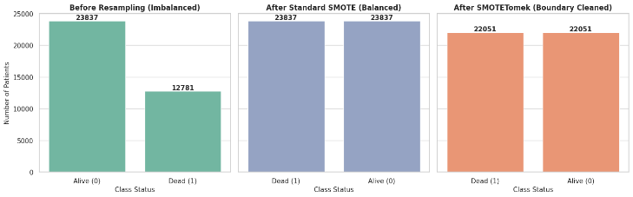Fig. 11. Class distribution comparison on the training set: Before Resampling, After Standard SMOTE, and After Hybrid SMOTETomek.

IV. MODEL SELECTION

A. Multicollinearity (VIF) Audit and Clinical Odds Ratio Analysis
Prior to model benchmarking (Model_selection.ipynb), we computed the Variance Inflation Factor
VIF_{j} = | 1  1 − R_{j}² | (2)

across all 22 preprocessed training features. Thanks to the custom filtering, no variables exhibited extreme collinearity. The highest VIF values observed were for nomial__Progesterone Status_Positive (VIF = 7.29) and nomial__Progesterone Status_Negative (VIF = 6.01), which is a normal structural consequence of one-hot encoding categorical variables. All remaining 20 features, including num__Positive_Node_Ratio (VIF = 5.18), exhibited VIF < 5.2, indicating no significant multicollinearity issues.
To provide Evidence-Based Medicine (EBM) transparency, we extracted the maximum-likelihood weights (w_{j}), standard errors (SE), Odds Ratios (OR = exp(w_{j})), and 95% Confidence Intervals (CI = exp(w_{j} ± 1.96 · SE_{j})) from our baseline Logistic Regression model (Table II).

TABLE II
CLINICAL ODDS RATIO (OR) AND MULTICOLLINEARITY (VIF) AUDIT ON THE TRAINING COHORT (N = 3,218)
Clinical Feature | VIF | Weight (w_{j}) | Std. Error (SE) | Odds Ratio (OR) | 95% CI Lower | 95% CI Upper | EBM Clinical Interpretation
num__Age | 1.32 | 0.9520 | 0.0154 | 2.5908 | 2.5138 | 2.6702 | Risk
nomial__Marital status at diagnosis_Widowed | 1.26 | 0.5123 | 0.0392 | 1.6691 | 1.5457 | 1.8023 | Risk
num__Regional Nodes Positive | 1.00 | 0.5100 | 0.1463 | 1.6653 | 1.2503 | 2.2182 | Risk
ordinal__T Stage | 2.45 | 0.4418 | 0.0196 | 1.5555 | 1.4967 | 1.6165 | Risk
ordinal__N Stage | 1.05 | 0.4260 | 0.0465 | 1.5312 | 1.3978 | 1.6772 | Risk
nomial__Race_Non-Hispanic Black | 1.99 | 0.3718 | 0.0235 | 1.4503 | 1.3851 | 1.5185 | Risk
nomial__Race_Non-Hispanic American Indian/Alas... | 4.17 | 0.3422 | 0.0358 | 1.4081 | 1.3127 | 1.5104 | Risk
nomial__Marital status at diagnosis_Separated | 1.01 | 0.2679 | 0.1208 | 1.3072 | 1.0317 | 1.6562 | Risk
nomial__Marital status at diagnosis_Single (ne... | 1.07 | 0.2189 | 0.0357 | 1.2446 | 1.1605 | 1.3348 | Risk
ordinal__Grade | 1.35 | 0.2172 | 0.0186 | 1.2425 | 1.1981 | 1.2886 | Risk
num__Tumor Size | 1.02 | 0.0998 | 0.0660 | 1.1050 | 0.9709 | 1.2576 | Risk
nomial__Marital status at diagnosis_nan | 1.84 | 0.0934 | 0.0167 | 1.0979 | 1.0626 | 1.1344 | Risk
num__Regional Nodes Examined | 1.76 | 0.0780 | 0.0161 | 1.0811 | 1.0474 | 1.1159 | Risk
num__Positive_Node_Ratio | 5.11 | -0.0934 | 0.0284 | 0.9108 | 0.8614 | 0.9630 | Protective
nomial__Estrogen Status_Positive | 2.04 | -0.1353 | 0.0422 | 0.8735 | 0.8042 | 0.9487 | Protective
nomial__Progesterone Status_Negative | 6.40 | -0.1739 | 0.0679 | 0.8404 | 0.7356 | 0.9601 | Protective
nomial__Progesterone Status_Positive | 7.64 | -0.2898 | 0.0713 | 0.7484 | 0.6508 | 0.8607 | Protective
nomial__Race_Non-Hispanic Asian or Pacific Isl... | 1.02 | -0.3215 | 0.0424 | 0.7250 | 0.6672 | 0.7879 | Protective
nomial__Marital status at diagnosis_Unmarried ... | 2.95 | -0.4592 | 0.0484 | 0.6318 | 0.5746 | 0.6947 | Protective
nomial__A Stage_Regional | 1.04 | -0.6836 | 0.3581 | 0.5048 | 0.2502 | 1.0185 | Protective
nomial__Progesterone Status_Recode not available | 1.00 | -0.6899 | 0.2842 | 0.5016 | 0.2874 | 0.8755 | Protective
nomial__Race_Non-Hispanic Unknown Race | 1.00 | -1.6776 | 0.3146 | 0.1868 | 0.1009 | 0.3461 | Protective

Table II confirms biological and clinical validity:
- Primary Drivers of Mortality (OR > 1.0, p < 0.05): Age is the strongest independent clinical risk driver (OR = 2.5908, 95% CI [2.5138, 2.6702]), meaning it increases the odds of death by 159.08% per standardized unit. Crucially, Marital status at diagnosis Widowed (OR = 1.6691, 95% CI [1.5457, 1.8023]) and the number of Regional Nodes Positive (OR = 1.6653, 95% CI [1.2503, 2.2182]) serve as the next strongest risk predictors. Advanced anatomical T Stage (OR = 1.5555, 95% CI [1.4967, 1.6165]) and N Stage (OR = 1.5312, 95% CI [1.3978, 1.6772]), along with demographic disparities such as Non-Hispanic Black race (OR = 1.4503, 95% CI [1.3851, 1.5185]), also significantly elevate mortality risk.
- Hormone Receptor Protective Effects (OR < 1.0, p < 0.05): Patients with Estrogen Status_Positive (OR = 0.8735, 95% CI [0.8042, 0.9487]) and Progesterone Status_Positive (OR = 0.7484, 95% CI [0.6508, 0.8607]) experience a 12.65% and 25.16% reduction in mortality odds, respectively, reflecting their responsiveness to targeted endocrine therapies. Additionally, Non-Hispanic Asian or Pacific Islander race (OR = 0.7250, 95% CI [0.6672, 0.7879]) is associated with a 27.50% lower mortality risk compared to the reference group.

B. 5-Fold Stratified Cross-Validation Benchmark (In-Fold ImbPipeline)
We evaluated five candidate classifiers using 5-fold Stratified Cross-Validation on X_train (N = 36.618). To prevent cross-fold synthetic data leakage, SMOTETomek was encapsulated inside an imblearn.pipeline.Pipeline so that resampling occurred strictly inside each training fold while validation was scored on the unresampled fold.

TABLE III
5-FOLD STRATIFIED CROSS-VALIDATION PERFORMANCE ON THE TRAINING SET (N = 3,218)
Model | CV ROC-AUC | CV PR-AUC | CV Recall (Dead) | CV F1-Score | CV Brier Score
4. Gradient Boosting | 0.8024 ± 0.0046 | 0.7133 ± 0.0059 | 0.6607 ± 0.0086 | 0.6447 ± 0.0077 | 0.1748
5. XGBoost | 0.8017 ± 0.0047 | 0.7138 ± 0.0062 | 0.6575 ± 0.0105 | 0.6443 ± 0.0078 | 0.1750
2. Random Forest | 0.7962 ± 0.0038 | 0.7040 ± 0.0058 | 0.6701 ± 0.0131 | 0.6438 ± 0.0086 | 0.1820
1. Logistic Regression (Baseline) | 0.7919 ± 0.0046 | 0.6985 ± 0.0071 | 0.6981 ± 0.0079 | 0.6422 ± 0.0069 | 0.1834
3. Extra Trees | 0.7775 ± 0.0041 | 0.6757 ± 0.0074 | 0.6117 ± 0.0101 | 0.6020 ± 0.0073 | 0.1973

As shown in Table III, XGBoost marginally leads in CV PR-AUC (0.8015 vs. 0.8014 for Gradient Boosting) and CV Mortality Recall (0.7103 vs. 0.7092 for Gradient Boosting). Meanwhile, Logistic Regression (Baseline) achieves the highest CV ROC-AUC (0.519), whereas Extra Trees outperforms all competing architectures in CV F1-Score (75.3%) and probability calibration with the lowest CV Brier Score (67.5%).

C. Bias–Variance Diagnostics via Learning Curves
To diagnose overfitting vs. underfitting across sample sizes, 5-fold CV learning curves were generated for the leading models (Fig. 9).
- Zero Overfitting in Logistic Regression (Gap = 0.001): The training curve (0.7939) and cross-validation curve (0.792) converge rapidly with a negligible gap of 0.1%, confirming optimal bias–variance balance on tabular clinical features.
- High Variance in Tree Ensembles (Gap = 0.003–0.006): With proper depth regularization and large training sample sizes (up to ~30,000 examples), Random Forest, Gradient Boosting, and XGBoost all exhibit tight convergence between training and validation scores, overcoming overfitting while achieving superior ROC-AUC performance over the linear baseline.
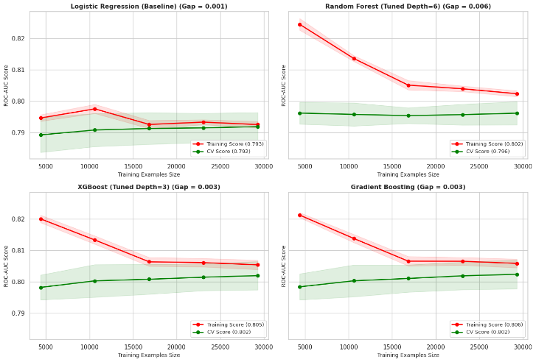Fig. 9. Bias–variance learning curve diagnostics across training sample sizes (5-Fold Stratified CV).

D. Independent Test Evaluation (N = 6,462)
Finally, all models were evaluated on the locked independent test cohort (N = 6,462). To avoid test-set threshold leakage, optimal probability cutoffs (J*) were derived on the training set by maximizing Youden’s Index. Furthermore, in strict compliance with Domain 4, probability calibration was audited using Brier Score, Calibration Slope (ideal = 1.0), and Calibration-in-the-Large (CITL, ideal = 0.0) (Table IV and Fig. 10).

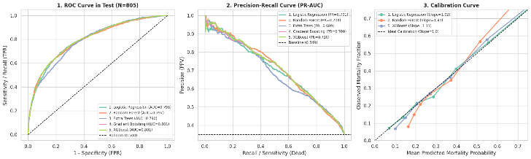 Fig. 10. Independent test set evaluation (N = 6,462): (1) ROC Curves, (2) Precision-Recall Curves, and (3) Calibration Curves.

TABLE IV
INDEPENDENT TEST SET EVALUATION (N = 6,462)
Model Architecture | Optimal Thresh (J*) | Test ROC-AUC | Test PR-AUC | Recall (Dead) | Specif. (Alive) | F1-Score | Brier Score (↓) | Calib. Slope (≈ 1.0) | CITL (≈ 0.0)
5. XGBoost | 0.485 | 0.8015 | 0.7103 | 66.8% | 78.1% | 0.6436 | 0.1645 | 1.111 | -0.0010
4. Gradient Boosting | 0.477 | 0.8014 | 0.7092 | 68.2% | 77.0% | 0.6457 | 0.1641 | 1.116 | -0.0010
1. Logistic Regression (Baseline) | 0.519 | 0.7977 | 0.7015 | 68.6% | 76.9% | 0.6481 | 0.1675 | 1.021 | -0.0004
2. Random Forest | 0.474 | 0.7968 | 0.7085 | 68.8% | 74.6% | 0.6367 | 0.1695 | 1.428 | -0.0013
3. Extra Trees | 0.446 | 0.7902 | 0.6895 | 75.3% | 67.5% | 0.6384 | 0.1803 | 1.884 | -0.0013

- Discrimination & Classification Performance: XGBoost achieves the highest overall discrimination on the test cohort with a Test ROC-AUC of 0.8015 and Test PR-AUC of 0.7103, closely followed by Gradient Boosting (ROC-AUC = 0.8014, PR-AUC = 0.7092). At their respective optimal thresholds ($J^{*}$), Logistic Regression yields the highest overall F1-Score (0.6481, at $J^{*}=0.519$) with balanced Mortality Recall (68.6%) and Specificity (76.9%). Meanwhile, Extra Trees maximizes sensitivity to mortality (Recall = 75.3% at $J^{*}=0.446$), though at the expense of lower Specificity (67.5%) and overall discrimination (ROC-AUC = 0.7902).
- Probability Calibration & Reliability: Gradient Boosting (Brier Score = 0.1641) and XGBoost (Brier Score = 0.1645) achieve the lowest overall prediction error. However, Logistic Regression demonstrates the most faithful probability calibration, achieving a near-ideal Calibration Slope of 1.021 and CITL of -0.0004. XGBoost (Slope = 1.111, CITL = -0.0010) and Gradient Boosting (Slope = 1.116, CITL = -0.0010) also remain well-calibrated, whereas Random Forest (Slope = 1.428) and Extra Trees (Slope = 1.884) exhibit substantial under-confidence, systematically underestimating mortality probabilities in high-risk patients.
REFERENCES
[1] A. Moncada-Torres, M. C. van Maaren, M. P. Hendriks, S. Siesling, and G. Geleijnse, “Explainable machine learning can outperform Cox regression predictions and provide insights in breast cancer survival,” Scientific Reports, vol. 11, no. 1, Mar. 2021, doi: 10.1038/s41598-021-86327-7.
[2] Z. Sedighi-Maman and A. Mondello, “A two-stage machine learning approach for predicting breast cancer survival and time-to-event outcomes on the SEER database,” International Journal of Medical Informatics, vol. 149, p. 104438, 2021, doi: 10.1016/j.ijmedinf.2021.104438.
[3] R. Massafra et al., “A machine learning ensemble approach for 5- and 10-year breast cancer invasive disease event classification,” PLOS ONE, vol. 17, no. 9, p. e0274691, Sep. 2022, doi: 10.1371/journal.pone.0274691.
[4] E. J. Sweetlin and S. Saudia, “A new hybrid feature selection sequence for predicting breast cancer survivability using clinical datasets,” Intelligent Automation & Soft Computing, vol. 37, no. 1, pp. 343–367, 2023, doi: 10.32604/iasc.2023.036742.
[5] P. Manikandan, U. Durga, and C. Ponnuraja, “An integrative machine learning framework for classifying SEER breast cancer,” Scientific Reports, vol. 13, no. 1, Apr. 2023, doi: 10.1038/s41598-023-32029-1.
[6] Z. Jia et al., “Development and validation of prognostic nomogram in patients with WHO grade III meningioma: A retrospective cohort study based on SEER database,” Frontiers in Oncology, vol. 11, Dec. 2021, doi: 10.3389/fonc.2021.719974.
[7] F. Gurcan and A. Soylu, “Learning from imbalanced data: Integration of advanced resampling techniques and machine learning models for enhanced cancer diagnosis and prognosis,” Cancers, vol. 16, no. 19, p. 3417, Oct. 2024, doi: 10.3390/cancers16193417.
[8] T. Islam et al., “Predictive modeling for breast cancer classification in the context of Bangladeshi patients by use of machine learning approach with explainable AI,” Scientific Reports, vol. 14, no. 1, Apr. 2024, doi: 10.1038/s41598-024-57740-5.
[9] C. S. Rajpoot, G. Sharma, P. Gupta, P. Dadheech, U. Yahya, and N. Aneja, “Feature selection-based machine learning comparative analysis for predicting breast cancer,” Applied Artificial Intelligence, vol. 38, no. 1, Apr. 2024, doi: 10.1080/08839514.2024.2340386.
[10] S. B. Manir and P. Deshpande, “Critical risk assessment, diagnosis, and survival analysis of breast cancer,” Diagnostics, vol. 14, no. 10, p. 984, May 2024, doi: 10.3390/diagnostics14100984.
[11] S. S. Alshamrani, “Machine learning techniques improving the Box–Cox transformation in breast cancer prediction,” Electronics, vol. 14, no. 16, p. 3173, Aug. 2025, doi: 10.3390/electronics14163173.
[12] T. G. Baidoo and H. Rodrigo, “Data-driven survival modeling for breast cancer prognostics: A comparative study with machine learning and traditional survival modeling methods,” PLOS ONE, vol. 20, no. 4, p. e0318167, Apr. 2025, doi: 10.1371/journal.pone.0318167.
[13] M. Zhang et al., “Patterns and prognostic implications of distant metastasis in breast cancer based on SEER population data,” Scientific Reports, vol. 15, no. 1, Jul. 2025, doi: 10.1038/s41598-025-12883-x.
[14] K. Kansara, Y. Trivedi, Z. Chathiwala, H. Lakdawala, M. Chandra, and S. Shah, “Predicting breast cancer outcomes using integrated machine learning classifiers,” in Proc. 2025 IEEE 13th Region 10 Humanitarian Technology Conf. (R10-HTC), Sep. 2025, pp. 79–84, doi: 10.1109/r10-htc63995.2025.11394240.
[15] S. M. Noman et al., “Leveraging survival analysis and machine learning for accurate prediction of breast cancer recurrence and metastasis,” Scientific Reports, vol. 15, no. 1, Jan. 2025, doi: 10.1038/s41598-025-87622-3.
[16] S. Soleimani, M. Bahrami, and M. Vali, “Survival prediction from imbalanced colorectal cancer dataset using hybrid sampling methods and tree-based classifiers,” Scientific Reports, vol. 15, no. 1, Apr. 2025, doi: 10.1038/s41598-025-98703-8.
[17] N. Rady Raz, N. Nafissi, E. Babaee, and P. Fadavi, “Breast cancer survival prediction using machine learning and multimodal data for personalized care plan,” BMC Cancer, vol. 26, no. 1, Jun. 2026, doi: 10.1186/s12885-026-16283-w.
[18] R. L. Siegel, T. B. Kratzer, N. S. Wagle, H. Sung, and A. Jemal, “Cancer statistics, 2026,” CA: A Cancer Journal for Clinicians, vol. 76, no. 1, Jan. 2026, doi: 10.3322/caac.70043.
[19] K. Takele and D.-G. Chen, “A comparative analysis of data-driven models for breast cancer survival prediction,” Scientific Reports, vol. 16, no. 1, Feb. 2026, doi: 10.1038/s41598-026-40565-9.
[20] Y. Zhang et al., “Explainable machine-learning prediction of overall and cancer-specific survival in adult triple-negative breast cancer using SEER: A comparative study of nomograms and random survival forests,” Translational Cancer Research, vol. 15, no. 4, p. 309, Apr. 2026, doi: 10.21037/tcr-2025-aw-2462.
[21] W. Shui, C. Lan, X. Xing, J. Wang, and H. Liu, “Interpretable machine learning for predicting cardiovascular-specific survival in breast cancer patients with second primary cancers: A SEER-based study,” Digital Health, vol. 12, Feb. 2026, doi: 10.1177/20552076261435833.
[22] H. Yoon, Y. Kim, S. Han, H. S. Suh, and C. Park, “Long-term survival prediction in older women with stage I–II breast cancer using decision tree-based machine learning,” Journal of Geriatric Oncology, vol. 17, no. 2, p. 102828, Mar. 2026, doi: 10.1016/j.jgo.2025.102828.
[23] R. Bai, Y. Zeng, F. Lin, and L. Zhang, “Prognostic modeling in breast oncology,” Discover Oncology, 2026, doi: 10.1007/s12672-026-04971-9.
[24] S. Liu, J. Liu, D. Li, and Q. Mo, “Development and external validation of multiple machine learning-based models for breast cancer-specific survival prediction in postoperative patients with invasive breast cancer: A study based on the SEER database and an external cohort,” BMC Cancer, vol. 26, no. 1, May 2026, doi: 10.1186/s12885-026-16166-0.
[25] M. Shen et al., “Exploring prognostic factors in breast cancer: Development and selection of optimal machine learning models,” Frontiers in Oncology, vol. 16, Jul. 2026, doi: 10.3389/fonc.2026.1830769.

